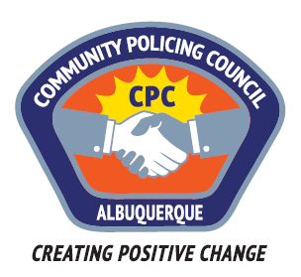

Valley Area Command Community Policing Council

AGENDA

April 27, 2017

APD Training Center
5412 Second St. NW
Albuquerque, New Mexico

6:00pm Call to Order (Edwina Kiro)
Roll Call
Approval of Agenda
Approval of Minutes

6:15pm “Police and Community Together Team (PACTT)” presentation by
Sergeant Nicholas Sanders

6:45pm “Review of Use-of-Force Incidents by the Civilian Police Oversight Board
and How the Process Works” presentation by Ed Harness, Executive Director,
Civilian Police Oversight Board

7:50pm Public Comment

8:00pm Adjourn

Next meeting: May 25, 2017

