Chapter 3: Birth of a New Paradigm
By Rex Funk

“The fallacy the economic determinists have tied around our collective neck, and which we now need to cast off, is the belief that economics determines all land use”. Aldo Leopold

1969 was, in many ways, the beginning of the open space movement in Albuquerque. The progress that followed in the next decade, complemented by the Albuquerque/Bernalillo County Comprehensive Plan for Major Open Space, was the largely the result of the efforts of four citizen advocacy groups. Later these groups united under the banner of the Open Space Task Force to advise the City in its early efforts to preserve Open Space.

Setting the Goals

In 1968, then City Councilor Pete Dominici formed the City/County Goals committee. The group was composed of community leaders who listened to public testimony about what the future of the City and County should be and distilled these concerns into long-range goals. Paul Lusk, then a City Planner and staff person for the Goals Committee, says they held a conference at D.H. Lawrence Ranch near Taos to work on goals. The results of their work were published and adopted in 1969, and included a revolutionary new goal for Open Space: “The goal is to preserve the unique, natural features of the metropolitan area by achieving a pattern of development and open spaces – respecting the river land, mesa, mountains, volcanoes, and arroyos.” What followed was the formation of four separate citizen advocacy groups, each advocating preservation of different elements of the natural setting: Save Our Sandias, Save the Arroyos, Save the Volcanoes, and the Bosque del Rio Grande Nature Preserve Society. Each of these groups had no more than a handful of active members, but they acted with great effect as champions and advocates for preserving their respective natural features.

The Advocates

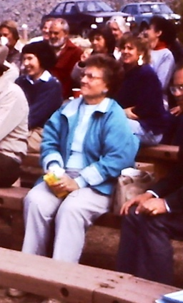
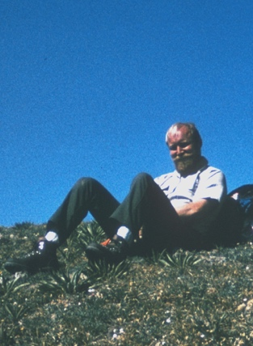
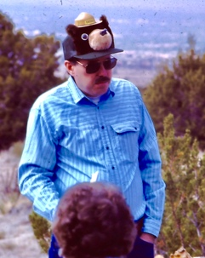
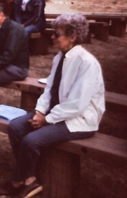
Save Our Sandias had its roots in the early 1970s when the Cibola National Forest, Sandia Ranger District proposed a trade of lands in Juan Tabo Canyon for lands in Embudo Canyon. This was a controversial proposal and was opposed at public meetings by several wilderness advocates and local residents. A leading voice in the opposition was Phillip B. Tollefsrud. Others were Mary Olin Harrell, Corry McDonald, Jay Sorenson, Milo Conrad, Victor Marshall, and Jack and LaDonna Kutz. The land swap was scuttled but Save Our Sandias was born and went on to lobby City, State, and Federal Governments to save lands along the foothills and all the way up to the crest of the mountain. Later, the group was joined by Vi Miller, Cliff Anderson and Jean House. They lobbied the New Mexico Congressional Delegation throughout the 1970s to save the Elena Gallegos grant, and their efforts ultimately contributed to the successful acquisition of that property (See Chapter 7).
Phil Tollufsrud
Mary Olin Harrel
Cliff Anderson
Jean House

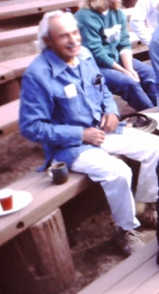
Save the Arroyos was led by Dr. Jim Lewis, a mathematics professor at UNM. Jim was a fixture at numerous meetings and was an advocate for natural treatment of arroyos He was a soft-spoken and colorful character who usually rode his bike to work and to meetings. Some of his ideas were eventually incorporated in AMAFCA projects, and hundreds of acres in the Tijeras Arroyo have been preserved. Jim was also an advocate of bike trails along the arroyos, and many of our most important trails are a result of his advocacy.
Jim Lewis

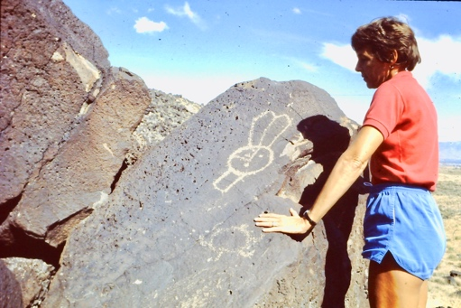
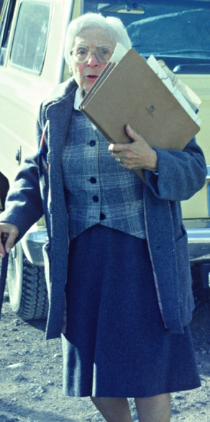
Save the Volcanoes was started by Ruth Eisenberg; also known as the “Volcano Lady”. Other active members were Eleanor “Ellie” Mitchell, Cliff Anderson, H. Barker Bill Weismantel, George Pearl, Bill Snead and Chris Rasmussen. Ellie Mitchell says the group held “Walk and Talks” on the escarpment and volcanoes featuring local experts on geology and biology. They also convinced a chamber orchestra to perform near Vulcan volcano. These events attracted hundreds of participants and helped elevate the importance of the volcanoes and escarpment. The tireless advocacy of this group led to the City acquiring all four major cinder cones on the West Mesa as well as thousands of acres of surrounding land. Had they not done so the land might have been developed into thousands of 5 acre “Ranchettes”. They also advocated for protection and fencing of this land, and an amphitheater. In the 1980s they successfully lobbied the City to acquire Piedras Marcadas Canyon; one of the largest concentration of petroglyphs along the volcanic escarpment. Together, these lands became the nucleus of Petroglyph National Monument (see Chapter 10).
Eleanor “Ellie” Mitchell
Ruth Eisenberg

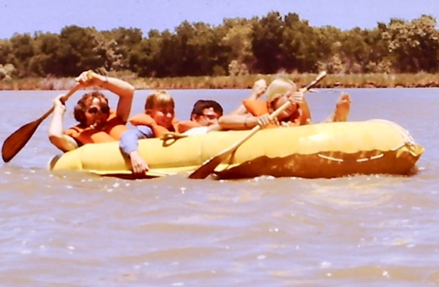
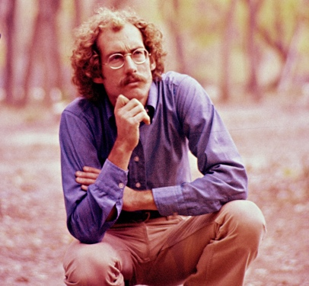
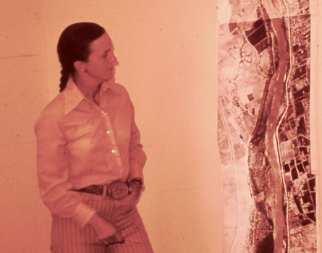
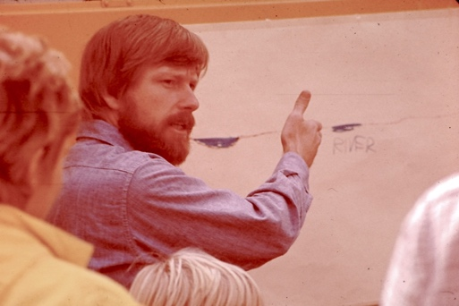
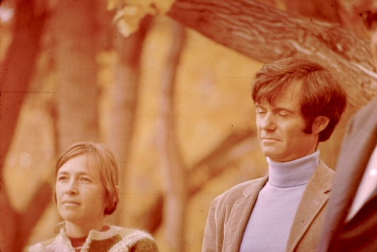
The Bosque Society was the group that I helped found in 1970. I had accepted a Science teaching position at West Mesa HS in 1969 and was interested in starting a nature center. I learned of a cat-tail marsh 2 miles north of our school in an old oxbow of the Rio Grande. It was fed by the outfall of the Corrales Drain, so it had a permanent water supply even when the River was dry. I visited it and found a high-quality 37-acre marsh teeming with wildlife. I heard of some people who were organizing to promote a nature preserve on the Rio Grande, and went to the first meeting at Saint Michaels and All Angels Church on Montano Rd. Joining me was Alan Templeton, a fellow biology teacher. The de-facto leader of the group was Harvey Frauenglass, a North Valley resident and technical writer for Sandia Corporation. Also present were Chan Graham, an architect; Caroly Jones, another North Valley Resident; and Steve Wilkes, an elementary school teacher. Later Blair Darnell, Dick Kirschner and Jay Thorndyke joined the group. We agreed to call ourselves the Bosque del Rio Grande Nature Preserve Society (later the Bosque Society) and discussed priorities. Public education was our first focus, and Harvey and a colleague, Ken Artz, produced a very professional narrated slide show which we presented to hundreds of groups and public officials. We also organized tours and field trips to the Bosque. The most successful of these were river rafting trips. We called ourselves the “Nature Preserve Navy” and our flagship was a 6-person yellow raft dubbed the “HMS Frauenglass”. Throughout the ‘70s we took scores of trips down the river during the spring runoff. We hosted planners, public officials, community organizers, the press, and other influential people as well as the public. Allen Templeton and I taught a summer field biology course focused on the Oxbow Marsh that offered college credit from the University of Albuquerque. Homer Milford, a Biology professor at U of A, was our sponsor. Little did we know that the Oxbow would be the scene of one of the most important battles in the history of the open space movement (see chapter 4). We worked with the City to get a National Endowment for the Humanities grant and helped produce the “City Edges Study” focusing on preserving the river and Bosque. We also worked toward establishing the Rio Grande Nature Center. (See Chapter 5)
Allen Templeton (left) on raft trip.
Steve Wilkes
Blair Darnell
Rex Funk giving a presentation
Caroly Jones & Harvey Frauenglass

The Open Space Task Force

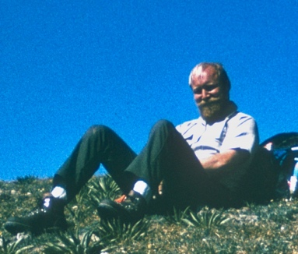
In the mid ‘70s, the City was receiving Land and Water Conservation Fund money from the Federal Government. This was matched with City bond issue funding, and the Planning Department wanted public input about priorities for acquisition of open space proposed in the Comprehensive Plan. Both the City and advocates wanted to avoid squabbling about priorities, so they agreed to form a “Citizen Open Space Task Force” to come up with a priority list based on objective criteria and consensus. The members of the task force were representatives of the four regional open space advocacy groups mentioned above and whoever else showed an interest. An early proponent and the first Chairman of the group was Phil Tollefsrud, a physicist at Sandia Corporation and wilderness advocate. His steady leadership, knowledge, diplomacy, and enthusiasm were essential in securing agreement of the parties on acquisition priorities. Phil was also a dynamic public speaker and credibly represented the Task Force at Planning Commission and City Council meetings. Working with the City, the Task Force advised on thousands of acres of Open Space acquisitions. (See Chapter 5)
Phil Tollefsrud

What qualities did these early open space pioneers have in common? First, they were united in being inspired by the land. They felt privileged to live in a City that had not yet overrun its natural setting. Many, like me, had experienced urban sprawl and destruction of open space elsewhere, but some were natives who loved the land and wanted to protect it. They were dedicated. They selflessly gave their time and energy to the effort to preserve open space. Some lived near Open Space and others did not. They came from a variety of backgrounds, experiences and skill sets. Engineers, teachers, professors, lawyers, artists, housewives, businessmen, architects, planners, and scientists all belonged to open space groups. They were effective because they were pragmatic. They focused on what would bring success. Finally, they were able to work together and with a variety of advocates, City staffers, journalists, politicians, and the public to get the message across and get action on their proposals. Speaking for many of us, Ellie Mitchell remembers the feeling of fun and accomplishment she had over several decades of involvement with open space. These and other groups greatly influenced the first Albuquerque/Bernalillo County Comprehensive Plan approved in 1975 and did much to implement it. (See chapter 5)

What I Learned:

“Don’t fight City Hall, convince them to do what you want”. I attribute this lesson to many activists with whom I worked and campaigns with which I was involved. Resistance has its place but changing the plan and getting it implemented; being proactive rather than reactive is the ultimate solution to permanently saving open space. Public support and advocacy are the engines that drive this change. The City County Goals Program, Comprehensive Plan, Rio Grande Valley State Park Plan and others all came out of this advocacy and became blueprints from which we built the open space system. Being for an alternative is more productive in the long run than being against the status quo. To lose a battle once is to lose that open space forever.

