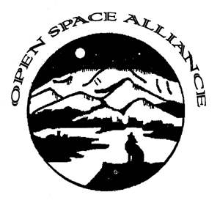
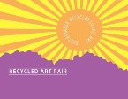
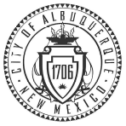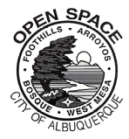
The City of Albuquerque
Open Space Visitor Center
Recycled Art Fair 2014 Application
Juried Art Exhibit – 17 and Under
__________________________________________________________________________________

The Open Space Alliance presents a Juried Recycled Art Exhibit in conjunction with the annual Recycled Art Fair at the Open Space Visitor Center for the months of March and April 2014. Selected works will appear in the main gallery.
Media Acceptable media must contain a minimum of 75% recycled materials.
The bulk of the material used must be “stuff” that would normally be discarded.
Though the primary focus in a traditional art show is the visual appeal of the piece, the criterion for this exhibit is the creativity demonstrated in transforming the material into something new and original.
Awards Awards for first place, second place and third place will be announced Sunday afternoon, April 27th during the Recycled Art Fair taking place Saturday and Sunday, April 26 and 27, 2014.
How to Enter There is a limit of two submissions per person. There is no jury fee required for submissions. I strongly encourage you to apply by submitting a digital application (email the form or include the contents of the form in the body of the email and submit digital images as an attachment no larger than 750 kb per image or a combined file size of 1.5 MB).
Applications should be emailed to:
Kim Selving at kselving@cabq.gov
If you would like to mail your application, please contact me for specific mailing directions.
There is no mail service at the physical address of the Open Space Visitor Center.

For additional information concerning your submission, please feel free to call me at (505) 897-8859. I am in the office Tuesdays – Saturdays.
THE DEADLINE FOR SUBMISSIONS IS February 25, 2014. Delivery of pieces occurs directly after (February 27-February 28).
Entrants will be notified of acceptance into the Open Space Recycled Art Fair Juried Art Exhibit by February 26th.
Sales If you choose to sell your artwork, please indicate this on the form below. A donation of 30% of Juried Art Exhibit sales goes to the Open Space Alliance, our non-profit partner.
Delivery & Pickup All work accepted into the exhibit must be delivered by Friday, February 28th 5:00 pm. If you are unable to deliver your artwork during that time, please contact us to make other arrangements. Work must be picked up by Tuesday, April 29th between 9:00 am and 5:00 pm. Work may also be picked up at 5:00 pm Sunday, April 27th, the end of the Recycled Art Fair.
Although the exhibit space at the Open Space Visitor Center will be locked and secured by alarm, the artist assumes responsibility for any damage, theft or loss of work.

----------------------------------------------------------------------------------------------------------------------------
[please print clearly]
Name_____________________________________________________________________
Address___________________________________________________________________
City, State, Zip______________________________________________________________
Phone: Day__________________________________Evening______________________
E-mail_________________________________
Title of Work________________________________________________________________
Materials___________________________________________________________________
Dimensions (Width-Height-Depth) __________________________________
If your work is for sale, please indicate price:____________

ARTIST STATEMENT
Please describe in 40-150 words the approach, philosophy or aim of your work. Include in this statement why you work with materials that would be discarded without being used to make art.
All submissions with this statement will be considered for the gallery show.

Thank you for your interest in participating.

