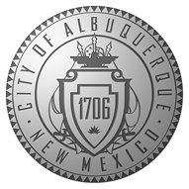
City of Albuquerque

Department of Municipal Development
Construction Coordination/Permits
505-924-3400

Dumpster/Storage Pod Application Form
Please email completed application to dmdccs@cabq.gov,
allowing at least 5 business days processing time.

Today’s Date:_________________________

Name:_______________________________________________________

Physical Address of Dumpster:____________________________________________________

City, State & Zip:_______________________________________________

Barricade Co:_________________________________________________

Office Phone:_________________________

Cell Phone:___________________________

Email:_______________________________________________________

Start Date:___________________ End Date:___________________

Note: Lighted barricades must be placed at the front and rear of a dumpster/storage pod. Please submit your application at least 5 business days before your anticipated start date. Permits labeled as “Payment Due” are NOT VALID until paid in full. Extensions to active permits may be requested by submitting an email request to dmdccs@cabq.gov with the permit number, desired date (not exceeding 30 days), and a reason if applicable.

