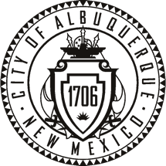
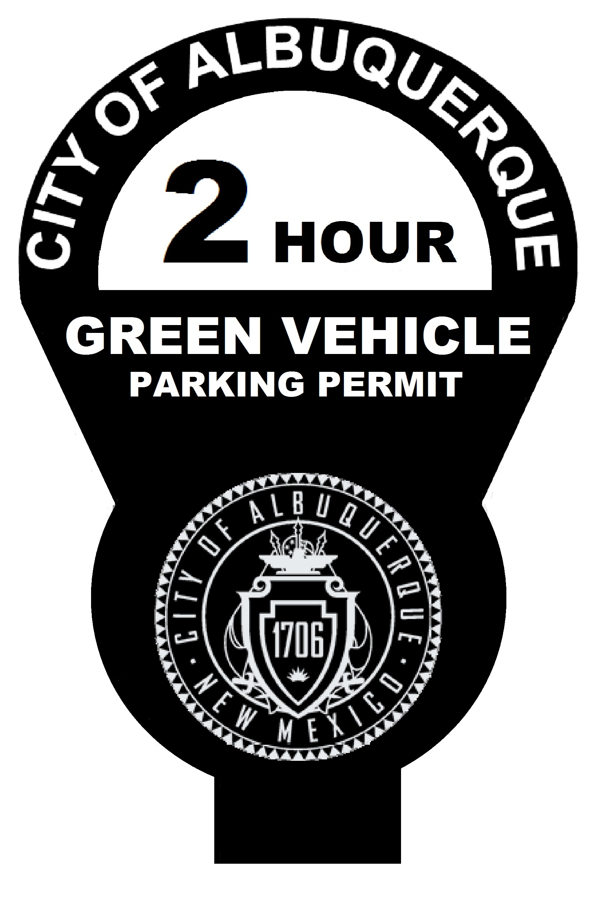
City of Albuquerque
Parking Division
Green Vehicle Registration
2017

** Applications and vehicle must be presented in person at the Parking Division office 600 2nd St NW Plaza Del Sol Building Suite 510. Applications will only be accepted Monday thru Friday from 9:00 am- 12:00 pm & 1:00 pm- 4:30 pm. Please bring with you your driver’s license, and current NM vehicle registration.

Owner: Cell Phone: Email:

Home Address: City: State: Zip Code:

Place of Employment: Business Phone:

Conditions for Permit
A Green Vehicle:
That is currently registered in the state of New Mexico and has a combined EPA score of 17 or greater.
Parked in a space regulated by an on street meter shall have the City issued identification:

- 2 hour time limit.
- Posted on the left rear bumper (Drivers Side) or rear window, bottom left side (Drivers Side).
- Permits are required to be renewed annually and expire on the last calendar day of December each year.
- The non-refundable $29.00 annual registration fee is to paid at the time of application. No personal checks accepted.
- VIOLATORS of this program such as application of the permit to an on qualifying vehicle could result in the revocation of the permit.

I agree to abide by the conditions listed above and in accordance to Ordinance 8-5-1-1, 8-5-1-2, 8-1-5-5 and 8-5-1-5C.

Owner Signature Date

FOR OFFICE USE ONLY

Receipt # Prorated: N Y Starting Month: Amount Collected $

Issued By: Date Entered: _______________ Auto Issue: Excel:

1st Score | 2nd Score | Total | Permit #
Must be 9 or higher |  | Must be 17 or higher

