INVESTIGATION REPORT

OF

FLEET ALLEGATION

DEPARTMENT OF FINANCE AND ADMINISTRATION SERVICES

FLEET MANAGEMENT DIVISION

REPORT NO. 10-202



City of Albuquerque

Office of Inspector General

INVESTIGATION
Department of
Finance and Administration Services

Fleet Allegation
Report No. 10-202
Executive Summary

Background: The Office of Inspector General (“IG”) conducted an investigation to determine whether or not there was probable cause to believe that a violation of criminal statutes was committed, specifically possible corruption and kickbacks at the Department of Finance and Administration (“DFAS”), Fleet Management Division (“Fleet”). This investigation was predicated upon a call to the IG in which the caller stated City employees and outside vendors were involved in corruption and kickbacks.

Objective: Is there evidence to support the allegation of corruption and kickbacks?

- City Employees accepted gifts in return for ordering parts from vendors.

The Albuquerque Police Department arrested Fleet Parts Worker A (“Suspect A”) and Fleet Parts Worker B (“Suspect B”). Both were charged with “Conspiracy” and “Soliciting or Receiving Illegal Kickbacks”. Suspect A and Suspect B are no longer employees of the City of Albuquerque.

Recommendation: DFAS, Fleet management should review the end of year inventory for 2010 to determine if there was a loss and to have the City’s Legal Department determine if any civil action can be taken against Suspect A and Suspect B

Objective: Are there areas in which DFAS can reduce the risk of fraud?

- Lack of Segregation of duties
- Inadequate staffing of Fleets parts units.

Recommendation: DFAS should:

- Ensure that key duties and responsibilities are divided among employees in the Fleet parts unit in order to reduce the risk of error or fraud. No one individual should control all key aspects of a transaction or event.

Ensure that there is adequate staffing at both of Fleets parts units to ensure that more that one employee is working in the parts unit. Without adequate staffing there is no segregation of duties which makes it easier for someone to commit fraud.

Management responses are included in the report.

ii

City of Albuquerque
Office of Inspector General

P.O. BOX 1293 ALBUQUERQUE, NEW MEXICO 87103

April 27, 2011

Accountability in Government Oversight Committee
City of Albuquerque
Albuquerque, New Mexico

Investigation: Fleet Allegation
DFAS-Fleet Management Division
10-202

FINAL

INTRODUCTION

The Office of Inspector General (“IG”) conducted an investigation to determine whether or not there was probable cause to believe that a violation of criminal statutes was committed, specifically corruption and kickbacks at the Department of Finance and Administration (“DFAS”), Fleet Management Division (“Fleet”). This investigation was predicated upon a call to the IG in which the caller stated City employees and outside vendors were involved in corruption and kickbacks.

BACKGROUND AND EVENTS

The City’s Fleet Management Division consists of two automotive repair shops. The two facilities are known as the Pino Yard Shop and the 6th Street Shop. The shops do repair and maintenance on the City's fleet of vehicles.

The Fleets parts unit uses several outside vendors to stock and order parts when needed. Fleet also sends vehicles out for repairs to several outside automotive repair/maintenance shops when needed.

INITIAL ALLEGATION REGARDING FLEET

The caller reported that a City employee at Fleet’s, 6th Street shop, Suspect I (Retired 01/02/2010) who was the Fleet shop supervisor would get quotes from 2 automotive shops and then call his friend at another automotive repair shop and let them know what the other 2 shops had quoted so that the friends shop could underbid the other two shops. The second allegation was that Suspect I was friends with one of the parts vendor owners the City did business with and that Suspect I would receive tickets to events from the owner.

The caller did state that the information given to the IG was given to the caller by another party who did not want to come forward at the time.

After performing the initial research into the allegations, the IG did not have any evidence at the time to proceed any further. Unless the person that the caller received the information from came forward, the IG could not proceed any further. The case was put on hold January 13, 2010.

SECOND ALLEGATION REGARDING FLEET

In early April 2010, the IG was contacted by the Albuquerque Police Department (“APD”), Deputy Chief (“DC”). The DC informed the IG that the APD had opened up a case on Fleet in January 2010 regarding a kickback scheme going on between City employees at the City’s Fleet shops and private vendors. The IG informed the DC that the IG had opened a case on fleet regarding kickbacks by a different City employee and different vendors, but that the case was on hold due to lack of evidence.

A confidential informant had given information to APD regarding a kickback scheme that was occurring between Company A, Company B and Company C and Fleet Parts Worker A (“Suspect A”) at Pino Yards and Fleet Parts Worker B (“Suspect B”) at 6th street.

The DC informed the IG that APD’s Property Crimes Division had begun an undercover investigation. The undercover individual (“UI#1”) would contact Suspect A to see what needed to be done to get business. In the initial meeting, Suspect A told the UI#1 how he received gift cards, lunches, and even a laptop from different vendors in return for ordering parts. Suspect A stated that if the UI#1 would agree to give him a percentage of purchases made, that Suspect A would start buying from the UI#1.

During the undercover operation, Suspect A informed the UI#1 that Suspect B was willing to participate in the kickback scheme as well. The UI#1 set up a time and location to meet with Suspect B. Suspect B asked for gift cards as long as they were not traceable in return for purchasing parts from the UI#1.

During the investigation period, UI#1 gave several gift cards to Suspect A and Suspect B for doing business with UI#1.

On April 2010 the IG joined APD in the investigation. The IG reviewed City documents, obtained City personnel information and interviewed City employees and vendors who did business with the Fleet Division. See Exhibit 3 to view a time line of events during the investigation.

On June 8, 2010 Suspect A was arrested and on June 9, 2010 Suspect B was arrested. Both were charged with “Conspiracy” and “Soliciting or Receiving Illegal Kickbacks”.

At the location where Suspect A was arrested there were four new tires found. Automotive parts were also located inside the vehicle driven by Suspect A. The

Fleet Analyst would later confirm that the tires and automotive parts found when Suspect A was arrested did belong to the City.

The IG assisted after the arrests were made by doing forensic analysis on documents confiscated in search warrants at the Pino shop and 6th street shop. Computer hard drives were also taken to the Federal Bureau of Investigation for analysis.

According to the Fleet Manager, Suspect A and Suspect B were the only employees assigned to the parts unit. Suspect A was at the Pino Yard parts unit and Suspect B at the 6th Street parts unit. The Fleet Manager stated that the Fleet Analyst was put in charge of the parts rooms back in August 2009 and physically moved to the Pino Parts room in March 2010. The Fleet Manager stated that the Fleet Analyst was put there because there was not a parts supervisor and that working in the parts unit was a little too much for one person.

When asked what would happen if Suspect A or Suspect B did not come to work, the Fleet Manager stated that the shop supervisor, lead mechanic or a mechanic would fill in for Suspect A or Suspect B.

The IG asked the Fleet Manager if any changes had been made after the arrests and resignation of Suspect A and Suspect B (June 16, 2010). The Fleet Manager stated that the Fleet Analyst is the only full time City employee and he is in charge of both the Pino parts unit and 6th Street parts unit. The Pino shop parts unit now has two part time contract employees and the 6th Street shop parts unit is still run by one individual, a contract employee.

Exhibit 1 and Exhibit 2 below list five vendor invoice totals paid by the City from January 1, 2010 through June 6, 2010. The exhibits show that the two vendors named in the kickback scheme received a majority of the business from both the Pino parts unit and the 6th Street parts unit.

Exhibit 1

64% of Parts sales went to the 2 vendors named in the kickback scheme.

Exhibit 2
The IG could not determine if Suspect I had committed any wrong doing as stated in the initial allegation. Suspect I is no longer a City employee, he retired in January 2010. The IG did not pursue that allegation any further.

OBJECTIVES

The objectives of the investigation were to determine:

- Is there evidence to support the allegation of corruption and kickbacks?
- Are there areas in which DFAS could reduce the risk of fraud?

SCOPE

The scope of the investigation was limited to:

- DFAS Employees
- Fleet Management Parts Vendors

METHODOLOGY

The methodologies used during our investigation consisted of:

- Analysis of available documents from the City and outside vendors;
- Interviews of City personnel and outside vendor personnel; and
- Analysis of City procedures and policies in effect regarding Fleet Management.

FINDINGS

The IG makes recommendations regarding areas noted during the investigation that we believe could improve the Department’s effectiveness, efficiency and compliance with administrative policies and applicable rules and regulations. These recommendations could prevent future fraud and provide controls that would detect fraud.

- City Employees accepted gifts in return for ordering parts from vendors.

Facts set forth present reasonable cause to believe that Suspect A and Suspect B violated the City Ordinance § 5-5-22 (D) (1) ROA 1994: Gratuities and Kickbacks which states:

It shall be unlawful for any person to offer, give, or agree to give any employee or former employee, or for any employee or former employee to solicit, demand, accept, or agree to accept from another person, a gratuity or an offer of employment in connection with any decision, approval, disapproval, recommendation, preparation or any part of a program requirement or a purchase request, influencing the content of any specification or procurement standard, rendering of advice, investigation, auditing, or in any other advisory capacity in any proceeding or application, request for ruling, determination, claim or controversy, or other particular matter, pertaining to any program requirement of a contract or subcontract, or to any solicitation or proposal therefore.

City Personnel Rules and Regulations (Code of Conduct §301.12) states:

Employees are responsible for preventing loss, damage, abuse, misuse or theft of City property or property entrusted to the City including, but not limited to: artifacts, vehicles, equipment, tools, supplies and City records. All City property should be used only for City Business. City property may not be used for personal gain or profit.

Fleet parts employees Suspect A and Suspect B solicited and accepted gift cards, lunches and a laptop in exchange for ordering automotive parts from vendors. Suspect A and Suspect B told certain vendors that if a vendor wanted business, the vendors would have to pay a certain percentage of sales in a gift card.

The Albuquerque Police Department arrested Suspect A and Suspect B. Both were charged with “Conspiracy” and “Soliciting or Receiving Illegal Kickbacks”. Suspect A and Suspect B are no longer employees of the City of Albuquerque.

Four tires were found at the location Suspect A was arrested, along with automotive parts found in Suspect A’s car. The Fleet Analyst verified that the tires and automotive parts belonged to the City.

RECOMMENDATION

DFAS, Fleet Management, should review 2010 year-end inventory to determine if there was a loss and refer the case to the Legal Department to determine if any civil action can be taken against Suspect A and Suspect B.

RESPONSE FROM DFAS

“The Fleet Management Division’s June 30, 2010 FY10 year-end parts inventory results are as follows:

“Pino Parts location was $28,736.71 short
“6th Street Parts location was $1,119.13 over

“As recommended, a copy of the inventory has since been forwarded to the City Attorney’s Office for review together with a request for advice regarding the potential for prosecution and or recovery.

“No schedule for the resolution of this matter has been established as of the date of this response.”

2. LACK OF SEPARATION OF DUTIES AND INADEQUATE STAFFING OF PARTS EMPLOYEES.

According to the Fleet Manager, Suspect A and Suspect B were the only employees assigned to the Fleet parts unit. Suspect A at the Pino Yard parts unit and Suspect B at the 6th Street parts unit.

Duties within the Fleet parts unit were not appropriately separated because the Fleets parts unit had one person dedicated to each location. Suspect A and Suspect B performed incompatible functions.

Governmental Accounting, Auditing, and Financial Reporting 2005 (Effective control-related policies and procedures; page 385) states:

Three types of functions are commonly considered to be incompatible: 1) authorization of transactions 2) record keeping and 3) custody of assets. No one individual should be able to authorize a transaction, record the transaction in the accounting records and maintain custody of the assets resulting from the transaction.

Suspect A and Suspect B were able to:

- Order, approve, receive, and issue parts, and record those
- transactions into the Fleet Focus system;
- Delete orders, invoices, and receipts in the Fleet Focus system; and
- Open closed work orders and assign additional parts and labor
- without supervisory approval.

RECOMMENDATION

DFAS should ensure that key duties and responsibilities are divided or segregated among employees in the Fleet parts unit in order to reduce the risk of error or fraud. No one individual should control all key aspects of a transaction or event. Issues that need to be addressed include the chain of custody over parts as they are received and issued to include who can:

- Order Parts
- Receive Parts
- Issue Parts
- Delete orders and receipts
- Re-open work orders to add or
- remove costs or quantities
- Adjust inventory quantities
- and costs
- Provide supervisory approval

DFAS should ensure that there is adequate staffing at both Fleets parts unit locations. Without appropriate segregation of duties it is easier for someone to commit fraud.

RESPONSE FROM DFAS

“A RFP seeking proposals for a private contractor to provide turn-key, on-time delivery parts supply services for both Pino Yards and 6th Street is scheduled to be published by April 26, 2011.”

Conclusion

This report includes findings pertaining to internal control and policy violations which contributed to the events set forth in this report.

Management has the responsibility for establishing an adequate system of internal controls, as well as Policies and Procedures. They should be communicated to Fleet employees so that they understand the consequences.

City employees are keepers of a public trust. To ensure that City employees do not violate this trust, an employee should not accept or request any gifts. City employees should not give preferential treatment to certain contractors in order to receive personal gain.

TIMELINE
FLEET MANAGEMENT INVESTIGATION
10-202
Exhibit 3
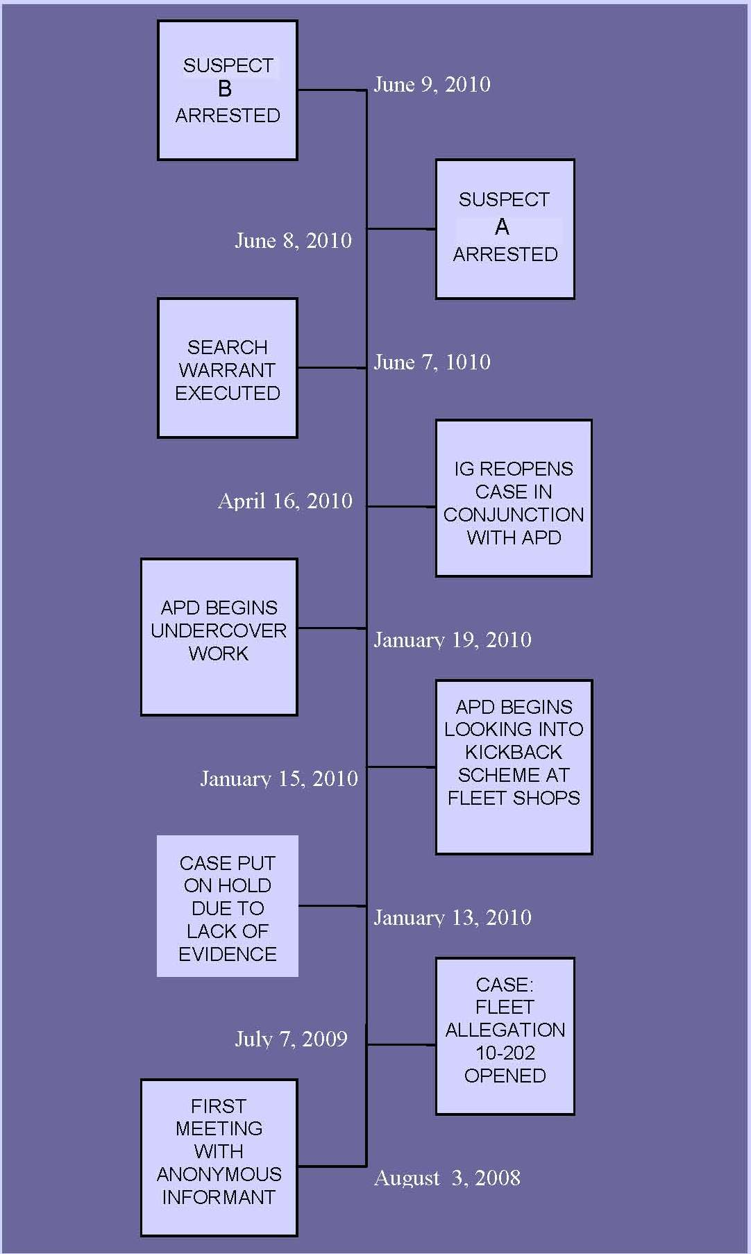
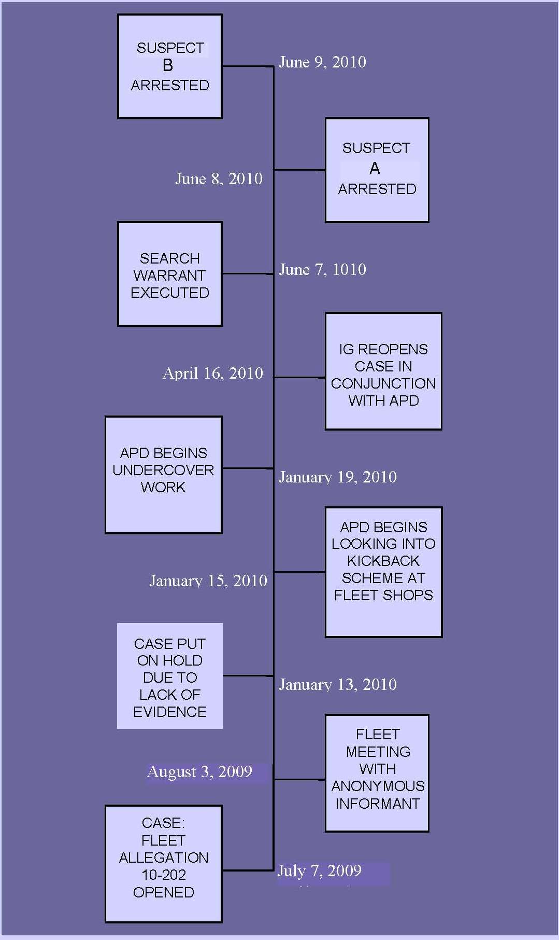

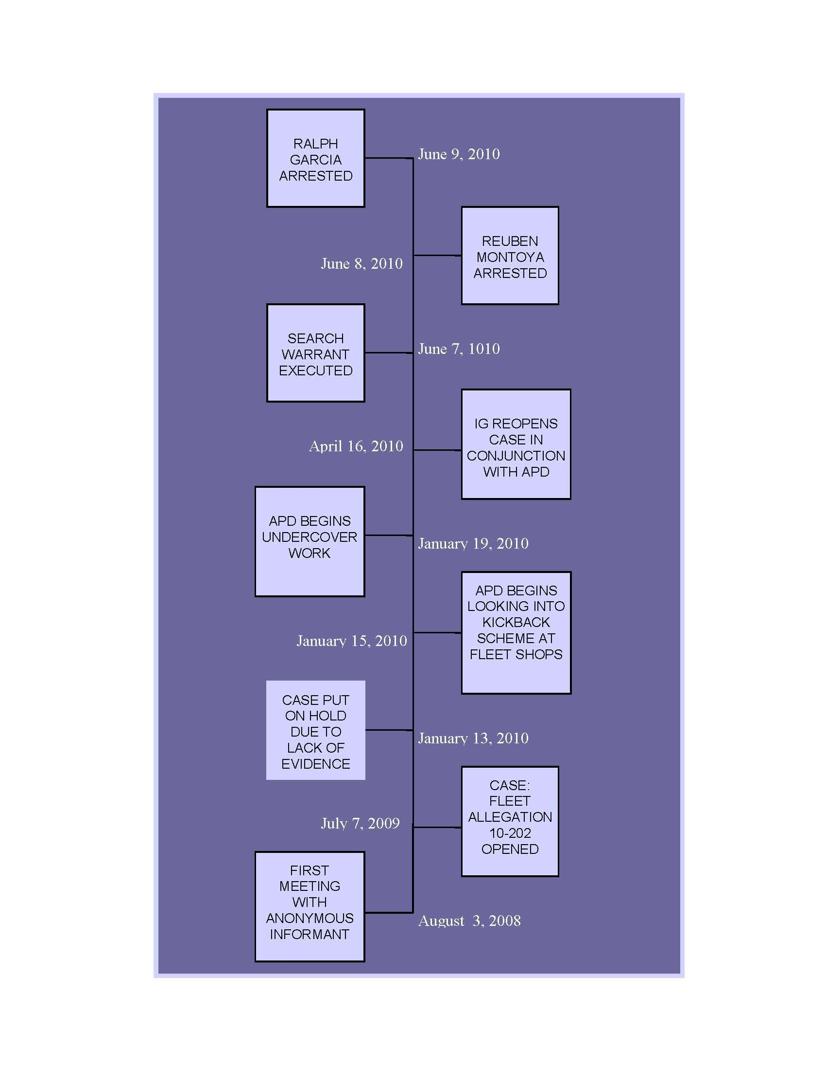

__________________________________
Principal Auditor/Investigator

REVIEWED: APPROVED FOR PUBLICATION:

__________________________________ ___________________________________
Carmen L. Kavelman, CPA, CISA, CGAP Chairperson, Accountability in Government
Director, Office of Internal Audit Oversight Committee

