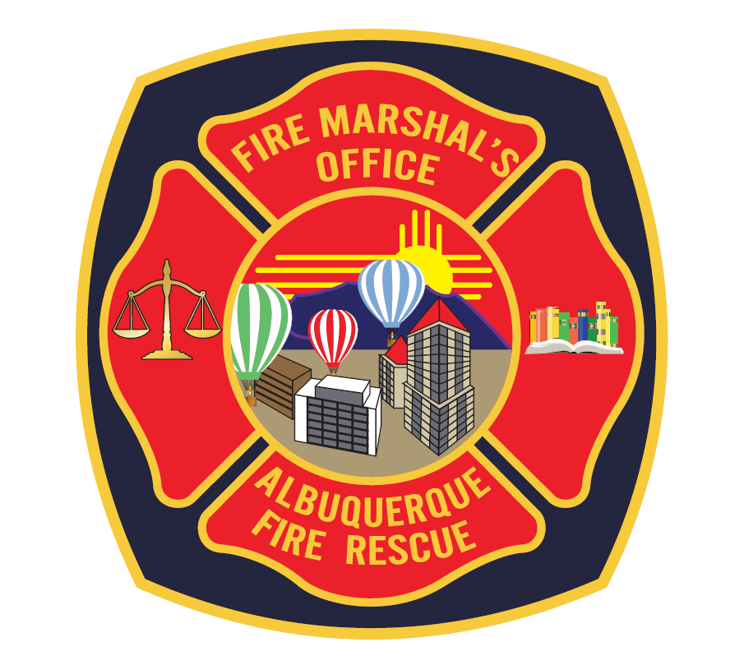 | Albuquerque Fire Marshal's Office  600 2nd Street NW  Albuquerque NM, 87102  Phone (505) 924-3611  Fax (505) 924-3619 | Tent Permit Application  □ Approved □ Disapproved  Case #_________ Date___________ Man#__________  Officers Signature______________________________
Approved plans do not guarantee the issuance of a permit. Final inspection is required confirming the event coincides with the approved plans.
Revised: 1/2020
Event Information
Event Name
Company Name
City |  | State
Street Name |  | Quadrant
Street Number |  | Zip Code
Contact Name
Contact Phone
Emergency Phone
Contact Email
Event Start Date
Event Start Time
Event End Date
Event End Time

Tent Provider
Company Name
City |  | State
Street Name |  | Quadrant
Street Number |  | Zip code
Contact Name
Contact Phone
Emergency Phone
Contact Email
Inspection Date
Inspection Time
Total Square Footage

Tent Requirements

CONSTRUCTION DOCUMENTS Detailed site and floor plan for tents shall be proved with each application for approval. The tent floor plan shall indicate means of egress, seating arrangement, heating and electrical equipment, exit signs, no smoking signs, fire extinguishers, cooking equipment, and exhibits. (IFC 3103.6)
LOCATION Tents or canopies shall not be located within 20 feet of lot lines, vehicles, or generators. All dimensions shall be indicated on the site plan. (IFC 3103.8.2)
DISPLAY OF MOTOR VEHILCES Vehicles and equipment used for display within or near tents shall have batteries disconnected, have less than ¼ of a tank of fuel, and tank openings shall be locked and sealed. Vehicles shall not obstruct the means of egress. (IFC 3104.18)
PROPANE GAS Tents or canopies shall not be located within 10 feet of propane tanks less than 500 gallons. (IFC 3104.16.2.1)
ANCHORAGE REQUIRED Tents or Membrane Structures and their appurtenances shall be adequately roped, braced or anchored to withstand the elements of weather and prevent against collapsing. (IFC 3103.9)
AIR INFLATED FUN JUMPS Air inflated fun jumps shall be approved on the site plan. (IFC 3103.4 and IFC 3103.2)
OCCUPANT LOAD The fire code official shall establish an occupant load for the assembly space and access controlled event. (IFC 3104.14)
COOKING All cooking and warming devices shall be indicated on the floor plan. Cooking appliance approvals shall be granted on a case by case basis. (IFC 3104.15)
VEGETATION AND WASTE Combustible vegetation and waste shall be cleared 30 feet back from tents or canopies. A description of the floor surface surrounding the tent or canopy and the floor within the tent or canopy shall be indicated on the floor plan. (IFC 3104.21)
COMBUSTIBLE MATERIAL Hay, straw, shavings or similar combustible materials shall not be located within any tent or canopy with an occupant load greater than 49 and or a square footage exceeding 750 square feet. A description of the floor surface inside the tent or canopy is required. (IFC 3104.5)
CLEARANCES There shall be a minimum clearance of 3 feet between tent walls and tent contents. All dimensions shall be indicated on the floor plan. (IFC 3104.11)
SMOKING Approved “No Smoking” signs shall be posted and indicated on the floor plan. Smoking shall be prohibited. (IFC 3104.6)
GENERATORS All generators shall be isolated from contact with the public by fencing or by other approved means. One 3A-40BC Fire Extinguisher is required per generator. Generator indications are required on the site plan. (IFC 3104.19)
FIRE EXTINGUISHERS A Fire Extinguisher shall be provided for every 1500 square feet of tent or canopy space. Travel distance to a Fire Extinguisher shall not exceed 75 feet. Extinguishers shall be indicated on the floor plan. (IFC 3104.12)
REQUIRED EXITS Equal or greater than: [150sqft 2 exits are required] [3,000sqft 3 exits are required] [7,500sqft 4 exits are required] [15,000sqft 5 exits are required] [30,000sqft 6 exits are required]. Exits must be spaced appropriately. (IFC 3103.12)
EXITS Exit openings shall be contrasting in color and be free sliding. Tent side walls or open wall canopies shall be indicated on the plans. (IFC 3103.12.3)
EXIT SIGN ILLUMINATION AND EMERGENCY LIGHTING Exit sign illumination and emergency lighting are required when the occupant load exceeds *49*. (IFC 3103.12.6)
EXTENSION CORDS Only approved UL, FM, or NRTL, three prong, grounded extension cords are permitted. Frayed or taped wire is prohibited. (IFC 605.5)
TENT MATERIAL All tent material shall meet “State of California Fire Marshal's Office” standards as per IFC Section 2404.2, NFPA 701, or CPAI-84. (IFC 3104.2)
ACCESS All Fire Hydrants and Fire Department appliances shall be free from obstructions. Fire Department access roads shall be a minimum or 20 feet. (IFC 3103.8.)
CHAIRS Non-fixed chairs exceeding 200 shall be fastened together in groups no less than three or securely fastened to the floor. (IFC 1029.14)
PERMITS All tents require permits. All canopies which exceed 400 square feet shall not be erected without obtaining a permit from our office. (IFC 2403.4)
TENT FEES [0-400sqft $50][401-1500sqft $100][1501-3000sqft $150][3001-6000sqft $200][6001-9000sqft $250][+9001sqft $300](105.7.15)
ADDITIONAL FEES Additional fees may apply for after hour inspections. (ORD 8306.1)
INSPECTIONS Inspection times shall be scheduled within four hours of the event opening. All electrical equipment, catering devices, tables, chairs, and merchandise shall be set in place prior to inspection. (ORD 3103.7.1)

Disclaimer

The undersigned herby acknowledges that all requirements indicated above must be adhered to in order for this application to be accepted. The standards specified above are the minimal requirements which the applicant is not limited to. Additional Fire Codes may apply during initial inspection if unforeseeable circumstances arise. An approved plot plan or floor plan does not guarantee the issuance of a permit. Final inspection is required confirming the event coincides with both the approved plot plan and floor plan. All disapprovals will be indicated on the tops of each page and all violations will be indicated with a check mark on this disclaimer. All information must be submitted to process this application. Revised 11/15/12.

EVENT CONTACT NAME: |  |  | PHONE NUMBER:
 | (PLEASE PRINT)
EVENT CONTACT SIGNATURE: |  |  | DATE:

TENT CONTACT NAME: |  |  | PHONE NUMBER:
 | (PLEASE PRINT)
TENT CONTACT SIGNATURE: |  |  | DATE:

OFFICERS COMMENTS: | Tent Permit Application  □ Approved □ Disapproved  Case #_________ Date___________ Man#__________  Officers Signature______________________________

