ECONOMIC DEVELOPMENT DEPARTMENT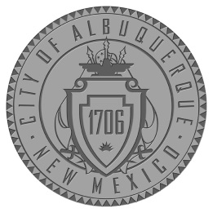
CITY OF ALBUQUERQUE

NOTICE OF MEETING
EDAct COUNCIL
Tuesday, March 25, 2014
11:30 a.m. - 1:30 p.m.
Office of the Mayor
Conference Room
One Civic Plaza Northwest
Albuquerque, New Mexico 87102

NOTICE TO PERSONS WITH DISABILITIES: If you are an individual with a disability who is in need of a reader, amplifier, qualified sign language interpreter, or any other form of auxiliary aid or service to attend or participate in the hearing or meeting, please contact Jennifer Walters, 1 Civic Plaza, 11th Floor, Albuquerque, NM 87102, (505) 768-3275, at least one week prior to the meeting or as soon as possible. Public documents, including the agenda and minutes, can be provided in various accessible formats. Please contact Jennifer Walters, (505) 768-3275, if a summary or other type of accessible format is needed.

