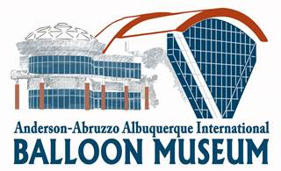
Agenda
Board of Trustees Virtual Meeting
Wednesday, November 11, 2020
3:00 - 4:30 pm, to be conducted via ZOOM web hosting

https://cabq.zoom.us/j/92622593792
Members: Nancy Abruzzo, Michael Anderson, Scott Appelman, Josh Bacon, Troy Bradley, Karen Brown, Peter Cuneo, Sid Gutierrez, J. D. Huss, Cindy Hernandez-Wall, Betty Ann McDermott, Angela Romero, Khristaan Villela

- Operating Procedures for online meetings per City Directive
  - Moderator controls access – concerned public may attend;
  - Open meeting must be recorded;
  - Speaker should identify him/her self at start of each statement;
  - All votes must be by roll call.
  - Please keep sound muted – press space bar to temporarily un-mute and talk

- Call to Order and Approval of Minutes (5 minutes)
- Election of Officers
  - Secretary
  - Vice-Chairperson
  - Chairperson
- Moving forward - new initiatives for our Board
  - Community Outreach
  - Fund Raising
  - Member ideas
- Manager’s Report
  - Museum Status
  - Personnel Updates
    - Welcome to Lynne S. Newton - Our new Exhibitions Curator
  - City Council proposed resolution on volunteer boards
  - New Exhibits
    - Inaugural Fine Art Competition & Exhibition
    - 50th Fiesta Exhibit
    - Women in Ballooning
  - City-Foundation MOU Negotiations
  - Master Plaque to honor past BOT members
  - FY2021 Strategic Plan
- Staff Reports
  - Collections & Registrar- Eric Wimmer
  - Exhibitions – Lynne Newton
  - Katie Farmin
- Foundation Report – Laurie Magovern
  - Preparations for 2021 Legislative session
  - Request for new committee members
- Adjourn Meeting

