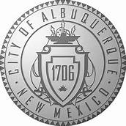
REQUEST FOR HEARING FORM
DISABLED PARKING CITATION
Complete this form: Fill in all of the blanks

You may bring this form to the Office of Administrative Hearings, 600 2nd Street NW, Suite 720, Albuquerque, New Mexico 87102 or mail to: Office of Administrative Hearings, P.O. Box 1293, Albuquerque, New Mexico 87103, to schedule your hearing.
You will be notified by mail within 90 days of receipt of this request, of the date, time and location of the hearing.

Print Name

Location of Incident

Address

Citation Number

Phone Number

Date Citation Issued

Car: Year, Make, Model

Car: Color, License Plate Number

Man Number of Issuing Officer

