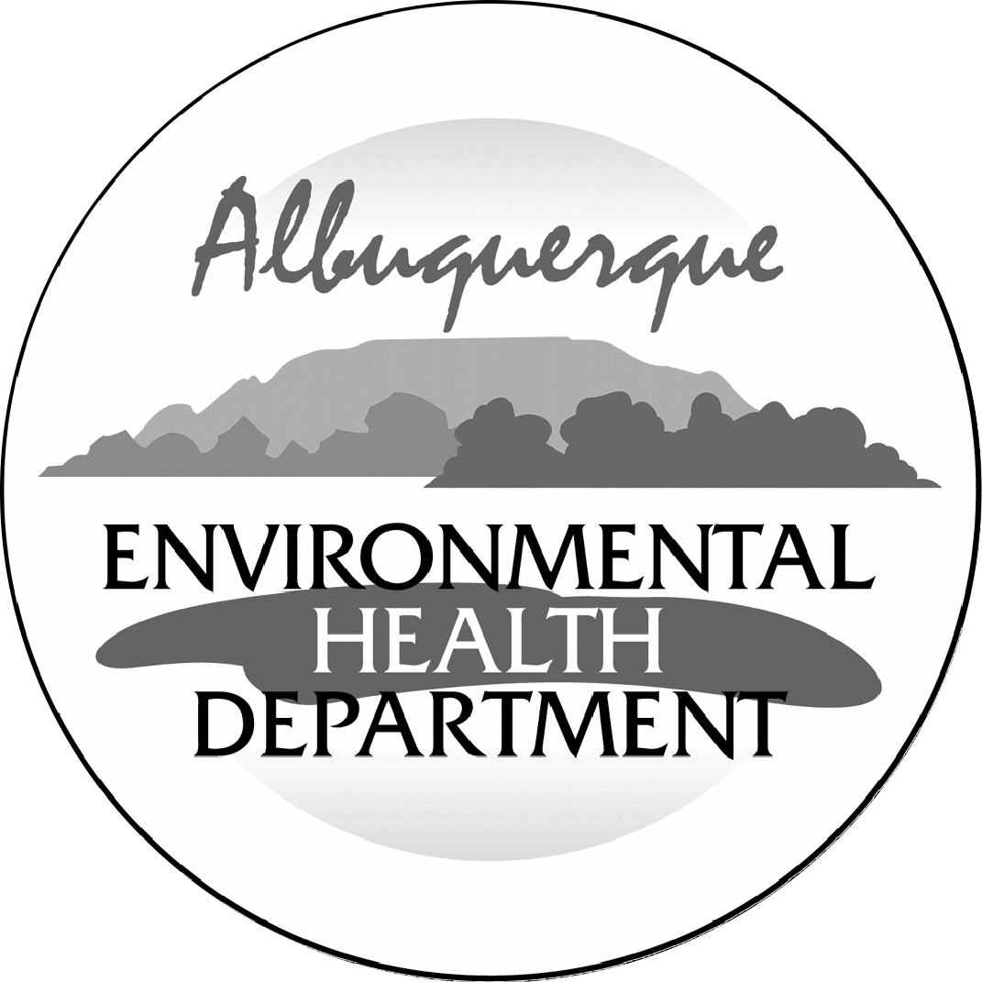
City of Albuquerque

Environmental Health Department

Air Quality Program

Permit Application Review Fee Instructions

All source registration, authority-to-construct, and operating permit applications for stationary or portable sources shall be charged an application review fee according to the fee schedule in 20.11.2 NMAC. These filing fees are required for both new construction, reconstruction, and permit modifications applications. Qualified small businesses as defined in 20.11.2 NMAC may be eligible to pay one-half of the application review fees and 100% of all applicable federal program review fees.
Please fill out the permit application review fee checklist and submit with a check or money order payable to the “City of Albuquerque Fund 242” and either:
- be delivered in person to the Albuquerque Environmental Health Department, 3rd floor, Suite 3023 or Suite 3027, Albuquerque-Bernalillo County Government Center, south building, One Civic Plaza NW, Albuquerque, NM or,
- mailed to Attn: Air Quality Program, Albuquerque Environmental Health Department, P.O. Box 1293, Albuquerque, NM 87103.
The department will provide a receipt of payment to the applicant. The person delivering or filing a submittal shall attach a copy of the receipt of payment to the submittal as proof of payment Application review fees shall not be refunded without the written approval of the manager. If a refund is requested, a reasonable professional service fee to cover the costs of staff time involved in processing such requests shall be assessed. Please refer to 20.11.2 NMAC (effective January 10, 2011) for more detail concerning the “Fees” regulation as this checklist does not relieve the applicant from any applicable requirement of the regulation.

City of Albuquerque

Environmental Health Department

Air Quality Program

Permit Application Review Fee Checklist

Please completely fill out the information in each section. Incompleteness of this checklist may result in the Albuquerque Environmental Health Department not accepting the application review fees. If you should have any questions concerning this checklist, please call 768-1972.

- COMPANY INFORMATION:
Company Name
Company Address
Facility Name
Facility Address
Contact Person
Contact Person Phone Number
Are these application review fees for an existing permitted source located within the City of Albuquerque or Bernalillo County? |  | Yes | No
If yes, what is the permit number associated with this modification? |  | Permit #
Is this application review fee for a Qualified Small Business as defined in 20.11.2 NMAC? (See Definition of Qualified Small Business on Page 4) |  | Yes | No

- STATIONARY SOURCE APPLICATION REVIEW FEES:
If the application is for a new stationary source facility, please check all that apply. If this application is for a modification to an existing permit please see Section III.
Check All That Apply | Stationary Sources | Review Fee | Program Element
Stationary Source Review Fees (Not Based on Proposed Allowable Emission Rate)
 | Source Registration required by 20.11.40 NMAC | $ 549.00 | 2401
 | A Stationary Source that requires a permit pursuant to 20.11.41 NMAC or other board regulations and are not subject to the below proposed allowable emission rates | $ 1,097.00 | 2301
 | Not Applicable | See Sections Below
Stationary Source Review Fees (Based on the Proposed Allowable Emission Rate for the single highest fee pollutant)
 | Proposed Allowable Emission Rate Equal to or greater than 1 tpy and less than 5 tpy | $ 823.00 | 2302
 | Proposed Allowable Emission Rate Equal to or greater than 5 tpy and less than 25 tpy | $ 1,646.00 | 2303
 | Proposed Allowable Emission Rate Equal to or greater than 25 tpy and less than 50 tpy | $ 3,291.00 | 2304
 | Proposed Allowable Emission Rate Equal to or greater than 50 tpy and less than 75 tpy | $ 4,937.00 | 2305
 | Proposed Allowable Emission Rate Equal to or greater than 75 tpy and less than 100 tpy | $ 6,582.00 | 2306
 | Proposed Allowable Emission Rate Equal to or greater than 100 tpy | $8,228.00 | 2307
 | Not Applicable | See Section Above
Federal Program Review Fees (In addition to the Stationary Source Application Review Fees above)
 | 40 CFR 60 - “New Source Performance Standards” (NSPS) | $ 1,097.00 | 2308
 | 40 CFR 61 - “Emission Standards for Hazardous Air Pollutants (NESHAPs) | $ 1,097.00 | 2309
 | 40 CFR 63 - (NESHAPs) Promulgated Standards | $ 1,097.00 | 2310
 | 40 CFR 63 - (NESHAPs) Case-by-Case MACT Review | $ 10,971.00 | 2311
 | 20.11.61 NMAC, Prevention of Significant Deterioration (PSD) Permit | $ 5,485.00 | 2312
 | 20.11.60 NMAC, Non-Attainment Area Permit | $ 5,485.00 | 2313
 | Not Applicable | Not Applicable

MODIFICATION TO EXISTING PERMIT APPLICATION REVIEW FEES:

If the permit application is for a modification to an existing permit, please check all that apply. If this application is for a new stationary source facility, please see Section II.
Check All That Apply | Modifications | Review Fee | Program Element
Modification Application Review Fees (Not Based on Proposed Allowable Emission Rate)
 | Proposed modification to an existing stationary source that requires a permit pursuant to 20.11.41 NMAC or other board regulations and are not subject to the below proposed allowable emission rates | $ 1,097.00 | 2321
 | Not Applicable | See Sections Below
Modification Application Review Fees
(Based on the Proposed Allowable Emission Rate for the single highest fee pollutant)
 | Proposed Allowable Emission Rate Equal to or greater than 1 tpy and less than 5 tpy | $ 823.00 | 2322
 | Proposed Allowable Emission Rate Equal to or greater than 5 tpy and less than 25 tpy | $ 1,646.00 | 2323
 | Proposed Allowable Emission Rate Equal to or greater than 25 tpy and less than 50 tpy | $ 3,291.00 | 2324
 | Proposed Allowable Emission Rate Equal to or greater than 50 tpy and less than 75 tpy | $ 4,937.00 | 2325
 | Proposed Allowable Emission Rate Equal to or greater than 75 tpy and less than 100 tpy | $ 6,582.00 | 2326
 | Proposed Allowable Emission Rate Equal to or greater than 100 tpy | $ 8,228.00 | 2327
 | Not Applicable | See Section Above
Major Modifications Review Fees (In addition to the Modification Application Review Fees above)
 | 20.11.60 NMAC, Permitting in Non-Attainment Areas | $ 5,485.00 | 2333
 | 20.11.61 NMAC, Prevention of Significant Deterioration | $ 5,485.00 | 2334
 | Not Applicable | Not Applicable
Federal Program Review Fees
(This section applies only if a Federal Program Review is triggered by the proposed modification) (These fees are in addition to the Modification and Major Modification Application Review Fees above)
 | 40 CFR 60 - “New Source Performance Standards” (NSPS) | $ 1,097.00 | 2328
 | 40 CFR 61 - “Emission Standards for Hazardous Air Pollutants (NESHAPs) | $ 1,097.00 | 2329
 | 40 CFR 63 - (NESHAPs) Promulgated Standards | $ 1,097.00 | 2330
 | 40 CFR 63 - (NESHAPs) Case-by-Case MACT Review | $ 10,971.00 | 2331
 | 20.11.61 NMAC, Prevention of Significant Deterioration (PSD) Permit | $ 5,485.00 | 2332
 | 20.11.60 NMAC, Non-Attainment Area Permit | $ 5,485.00 | 2333
 | Not Applicable | Not Applicable

ADMINISTRATIVE AND TECHNICAL REVISION APPLICATION REVIEW FEES:

If the permit application is for an administrative or technical revision of an existing permit issued pursuant to 20.11.41 NMAC, please check one that applies.
Check One | Revision Type | Review Fee | Program Element
 | Administrative Revisions | $ 250.00 | 2340
 | Technical Revisions | $ 500.00 | 2341
 | Not Applicable | See Sections II, III or V

PORTABLE STATIONARY SOURCE RELOCATION FEES:

If the permit application is for a portable stationary source relocation of an existing permit, please check one that applies.
Check One | Portable Stationary Source Relocation Type | Review Fee | Program Element
 | No New Air Dispersion Modeling Required | $ 500.00 | 2501
 | New Air Dispersion Modeling Required | $ 750.00 | 2502
 | Not Applicable | See Sections II, III or V

- Please submit a check or money order in the amount shown for the total application review fee.

Section Totals | Review Fee Amount
Section II Total | $
Section III Total | $
Section IV Total | $
Section V Total | $
Total Application Review Fee | $

I, the undersigned, a responsible official of the applicant company, certify that to the best of my knowledge, the information stated on this checklist, give a true and complete representation of the permit application review fees which are being submitted. I also understand that an incorrect submittal of permit application reviews may cause an incompleteness determination of the submitted permit application and that the balance of the appropriate permit application review fees shall be paid in full prior to further processing of the application.

Signed this___________ day of ________________________ 20____

______________________________ _________________________________
Print Name Print Title

______________________________
Signature

Definition of Qualified Small Business as defined in 20.11.2 NMAC:
“Qualified small business” means a business that meets all of the following requirements:
(1) a business that has 100 or fewer employees;
(2) a small business concern as defined by the federal Small Business Act;
(3) a source that emits less than 50 tons per year of any individual regulated air pollutant, or less than 75 tons per year of
all regulated air pollutants combined; and
(4) a source that is not a major source or major stationary source.

Note: Beginning January 1, 2011, and every January 1 thereafter, an increase based on the consumer price index shall be added to the application review fees. The application review fees established in Subsection A through D of 20.11.2.18 NMAC shall be adjusted by an amount equal to the increase in the consumer price index for the immediately-preceding year. Application review fee adjustments equal to or greater than fifty cents ($0.50) shall be rounded up to the next highest whole dollar. Application review fee adjustments totaling less than fifty cents ($0.50) shall be rounded down to the next lowest whole dollar. The department shall post the application review fees on the city of Albuquerque environmental health department air quality program website.

