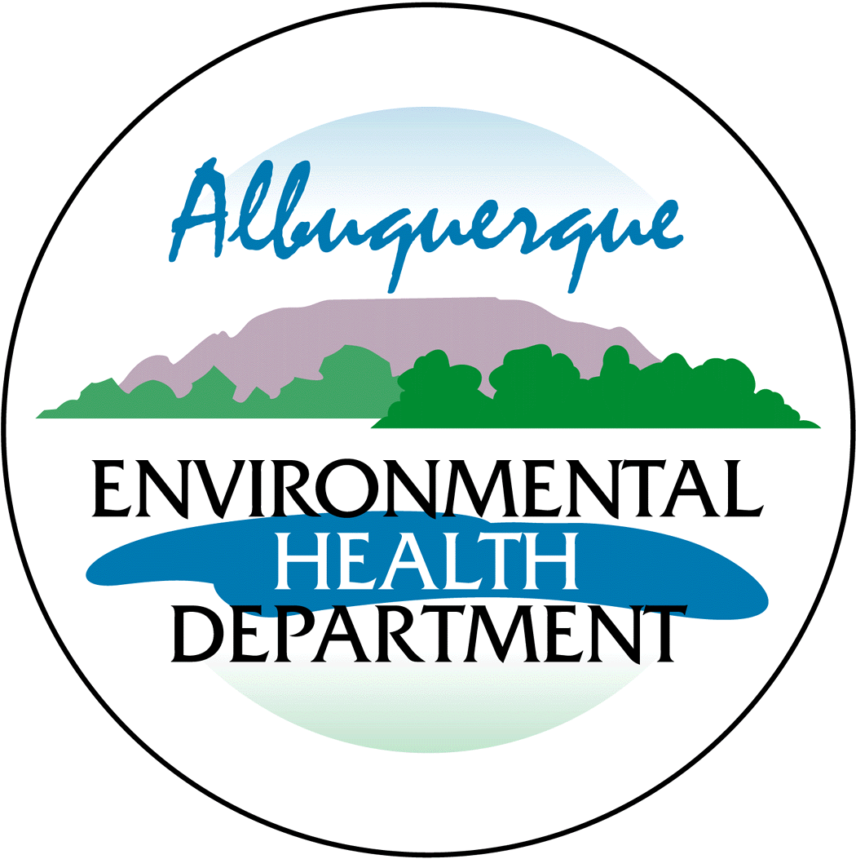
Pre-Permit Application Meeting Request Form

Air Quality Program- Environmental Health Department

Please complete appropriate boxes and email to aqd@cabq.gov or mail to:

Environmental Health Department
Air Quality Program
P.O. Box 1293
Room 3047
Albuquerque, NM 87103

Name:
Company/Organization:

Point of Contact:  (phone number and email):  Preferred form of contact (circle one):  Phone E-mail | Phone:  Email:
Preferred meeting date/times:
Description of Project:

